Introduction To jenkins

First we need to download jenkins war file. Then we can launch the jenkins with the help of terminal.

Download the jenkins war file.

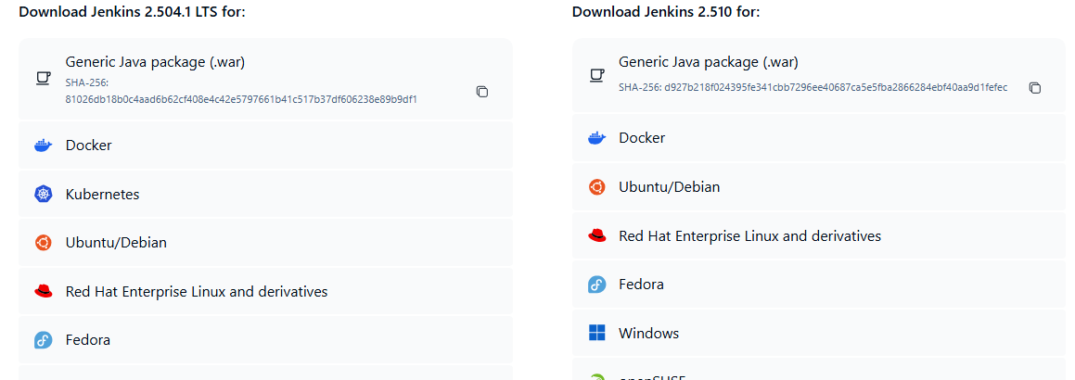

Open terminal-> enter the full path where the jenkins war file present

Enter the command :- java -jar jenkins.war httpPort=8080

When I hit this command its given the password in below.

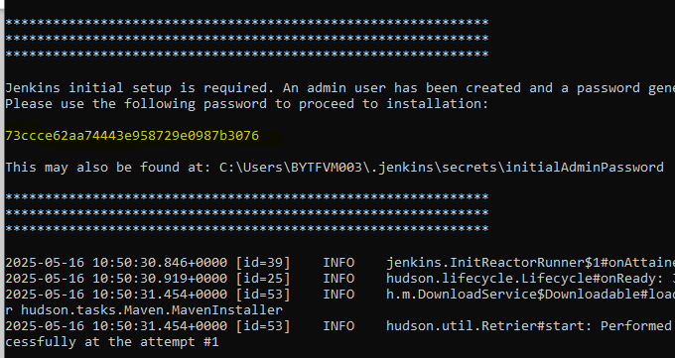

Make sure this is not aborted if its come outside from the command then its not launch the jenkins

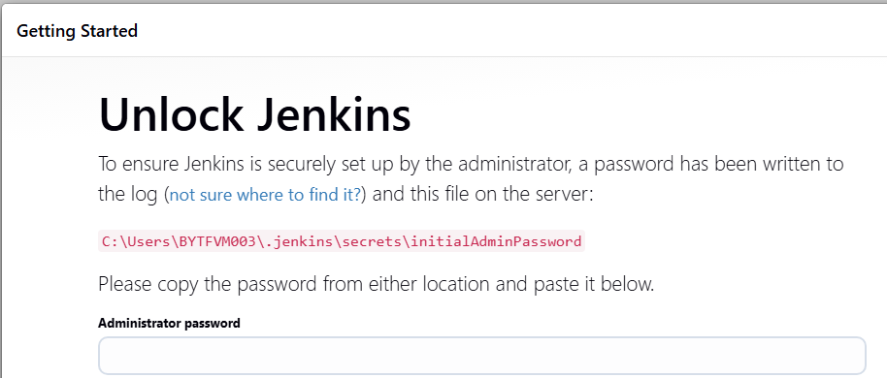

Integrating Cypress framework with jenkins CI tool

Lets assume jenkins has been launched-> move to manage jenkins -> Plugins-> install nodejs .

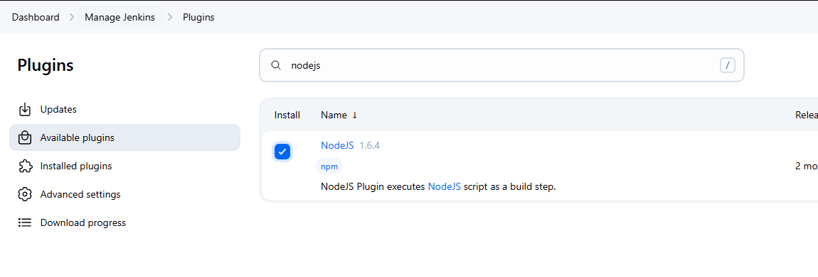

Next Configured node js in the project wise. Navigate to Manage jenkins->Tools-> click on Nodejs-> Install Automatically

In the fields we only provide name as version only remaining all fields as its no need to give any value .

Then save and apply.

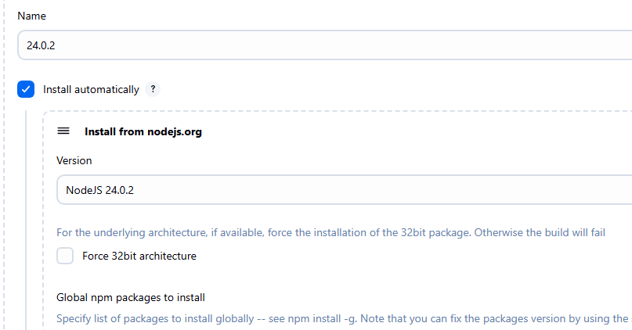

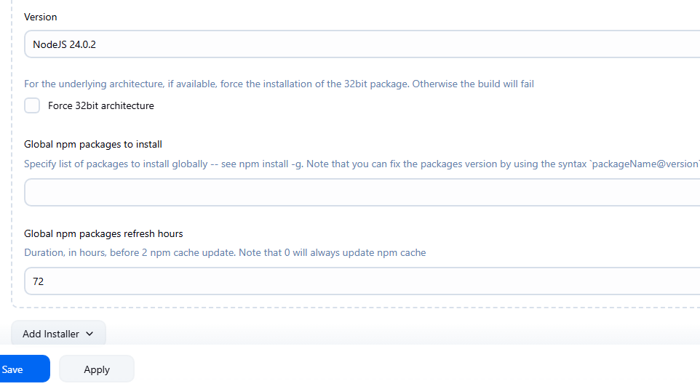

Now we need to create a project , choose the freestyle project. With name as cypress_framework

To run the project we need to give the path of the project . As jenkins running on local so it will take the local project path .

So we can choose the custom workspace path under General Tab.

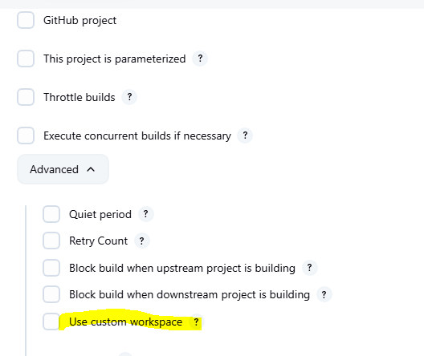

Take the path of the project

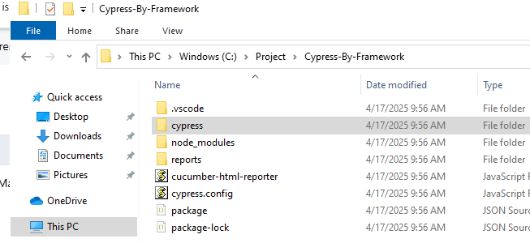

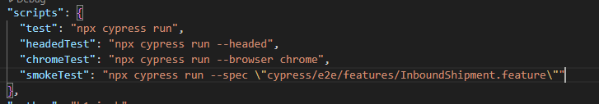

As per the above screen shot we can take the script with test only

Steps to configured the job

1. Set the path of the project

1. Give identification to jenkins to know the NPM

1. Build step execution

Error faced:-

Facing file not found error mainly

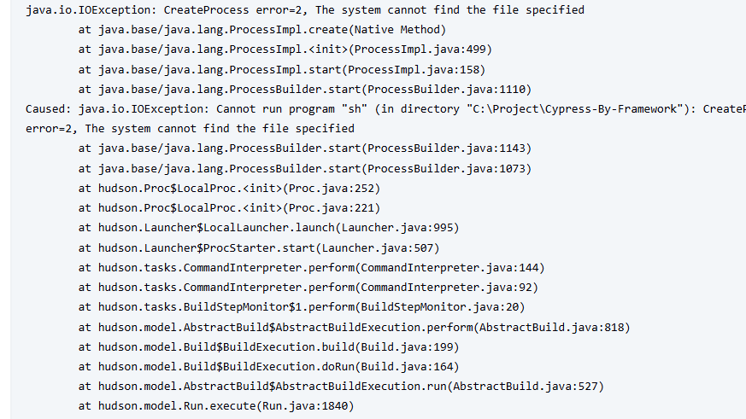

Cause of this error because the execution we have set under shell and Node JS. That’s why for windows execution we need to set up the bat file execution or powershell execution for the build execution section.

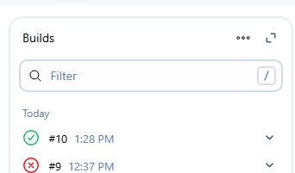

Finally the build has been executed successfully . But the build execution we have set hard coded like npm run test. We need to set as parameter because this thing we can manage at run time .

Choose the parameter under general tab section. Option select as choice parameter.

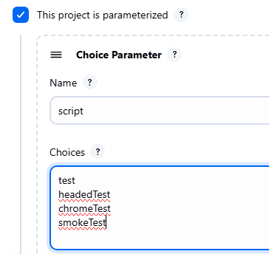

Also we need to change the script value in build schedule

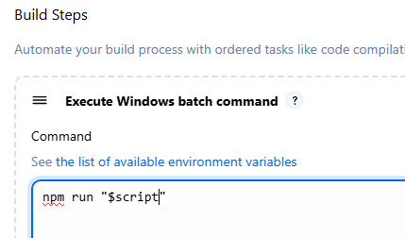

For bat file execution we need to take the script value as

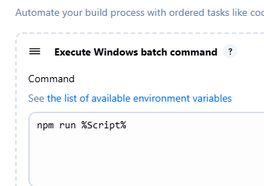

We can see the build as parameter

